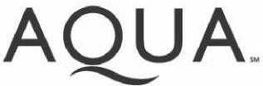 | OWNER/LANDLORD REVERT PERMISSION  FORM  Aqua ACO  Collections Department  762 W. Lancaster Avenue, Bryn Mawr, PA 19010  877.987.2782

I hereby agree that I will be responsible for all Aqua services at the following address(es) when a tenant moves out:
Owner/Landlord Name (please print):

SSN# or Driver’s License #:
Service Address(es):
Please put the account in my name when the tenant at the above address(es) notifies Aqua that he or she is moving out of the property and will no longer be responsible for the service. *Written notification will be sent to Illinois owners/landlords each time the account is placed in their name.
Please mail this notice and/or bills to me at:
Address:
Daytime Phone:
I understand that I can cancel this request at any time by notifying Aqua at the above address. Owner/Landlord Signature:

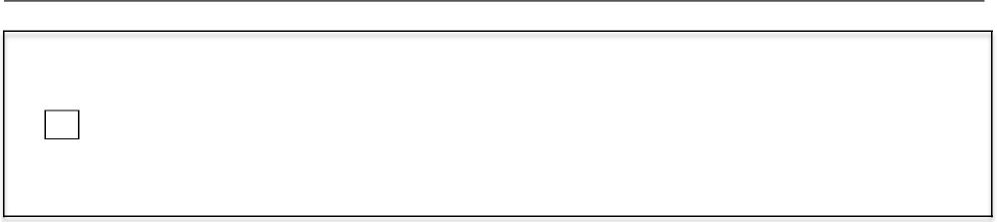
Illinois Owner/Landlord Only:
I do not want to be notified each time the service is placed in my name. I understand that I can opt out of receiving notification at any time by contacting Aqua at the above address or telephone number.
Date:

Please mail this form to Aqua at the address above or fax it to 866.780.8301 or 610.520.2168.

